The GKK Tools Editor Feature Set

- Color Syntax Highlighting. VFP-specific keywords, comments, and strings are colored differently to set them apart from plain text. Bold, italics, and underline are supported per keyword set.
- Change Control. Lines that have changes are indicated with a yellow change bar in the left margin.
- Bookmarks. User can toggle on/off bookmarks for fast navigation.
- Fully Customizable Keyboard Mappings. Keystrokes can be added and removed to emulate popular keyboard mappings like Brief and Epsilon.
- Keystroke Macros. Users can record a series of keystrokes and assign a keystroke to play back the keystrokes repeatedly. Up to 10 macros may be recorded.
- Multiple Split Views. Users can create up to four separate views of the same edit buffer. Each view can be scrolled independently.
- Unlimited Undo/Redo. All edit actions are fully undoable and redoable. A limit can be set on the number of undoable actions.
- Regular Expression Searching. Perform regular expression searching and replacing using Perl-like regular expressions.
- Auto Indentation. Editor automatically indents lines to following the scoping rules of the active language.
- Drag and Drop Text Manipulation. Highlighted text can be dragged and dropped between any window supporting OLE text Drag and Drop. Text may be copied or moved.
- Clipboard Support. Text can be cut, copied and pasted onto the clipboard using the right-click menu or a keystroke.
- RTF Clipboard support. Text copied or dragged from the edit buffer can be pasted into other applications with all formatting information intact.
- Column Selection and Manipulation. Select text as a column rather than a paragraph. Empty columns (columns with a width of zero characters) can be selected, causing subsequent typing and deletion to occur over multiple lines at the same time.
- Printing Support. Print portrait or landscape modes, with or without line numbering, intelligent word-wrapping of long lines. Colored text supported. Print preview mode.
- Custom Color Settings. All foreground and background colors used in a Editor control are configurable by the end-user.
- Built-In Right Click Menu. A set of commonly used commands are available from a default right-click menu.
- Microsoft IntelliMouse Support. Scrolling, word selection, and line selection is easily accomplished with the Microsoft IntelliMouse.
- Microsoft Windows XP Theming Support. All elements of the Editor user interface automatically adapt to the current Windows theme when running on Windows XP.
- Over 150 Separate Edit Commands. More than 150 separate edit commands can be assigned to a keystroke and invoked by the user.
- Line Numbering. Lines can be numbered using any radix and the first line may start with any positive number.
- Keyword Case Normalization. Keywords can be converted to the proper case once a line is entered.
- Virtual Space. The text caret can optionally be confined to the bounds of the text or allowed to move beyond the end of a line.
- Hyperlinks. Hyperlinks embedded in code are highlighted differently and can be navigated by the user.
- Line Sorting. Lines can be sorted alphabetically in ascending or descending order.
- Code Completion. Display memberlist popup windows, parameter info tooltips, QuickInfo tooltips, and auto-complete partially typed identifiers.
- Code Tips. Command tips are displayed by hovering the mouse over a command keyword or during keyboard entry.
- Automatic Brace Match Highlighting. Matching braces are highlighted as users type.
- Command block highlighting. Command blocks such as IF … ENDIF are highlighted for matching blocks for quick reference.
- Incremental Search. Users can search for text while Editor automatically selects the best match after each character is typed.
- Comment/Uncommenting Support. Blocks of code can be commented and uncommented via built in commands.
- Automatic Font Resizing. Users can change the font size simply by holding the control key down and spinning the mousewheel (Ctrl + MouseWheel).

The GKK Editor Window Features

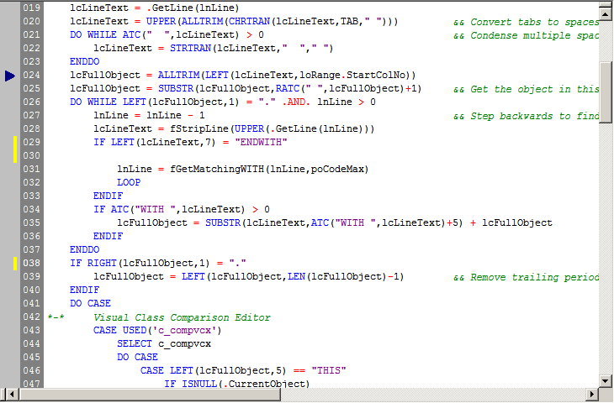
Bookmarkers
Change line indicator
Code Highlighting

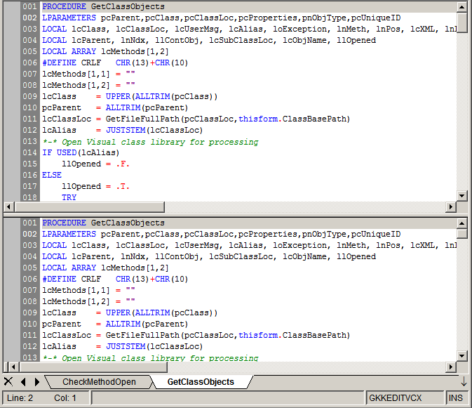
Split screen mode (horizontal and vertical) for independent navigation within a single method
MDI Tabs for selection between methods
Line numbering
Close tabs and scroll tabs for display
Drop-down Menu for quick tab selection
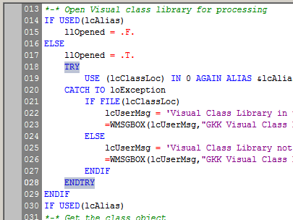
Code block highlight when cursor placed on block

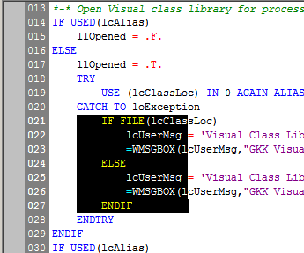
Column selection mode (hold Alt key with mouse selection)

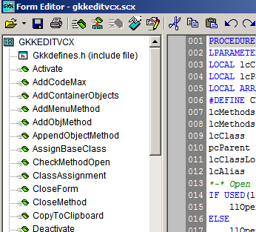
GKK Form Editor provides Treeview for fast navigation of methods and objects in a form
DocView is opened/closed (refreshed when opened)
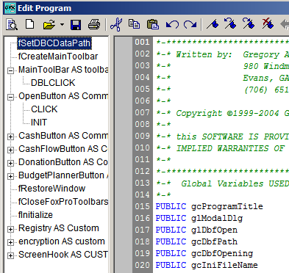
GKK Procedure Editor provides DocView for fast navigation of classes and procedures in a file (references updated dynamically as code is edited)

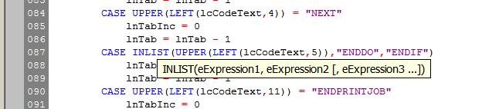
Tooltips – hoover mouse over VFP keyword for tip

During scroll with mouse, displays line number in tooltip

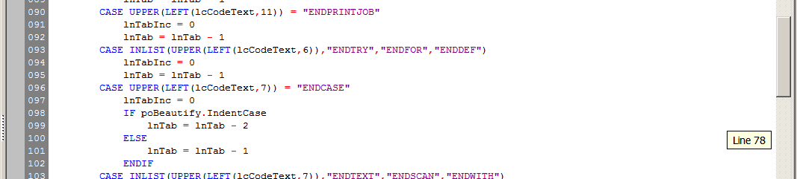

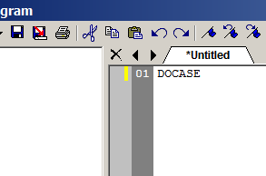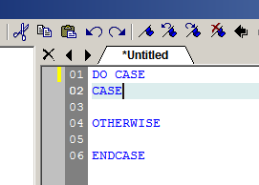
Command Completion

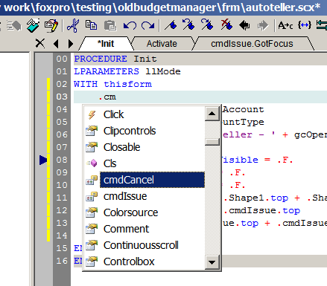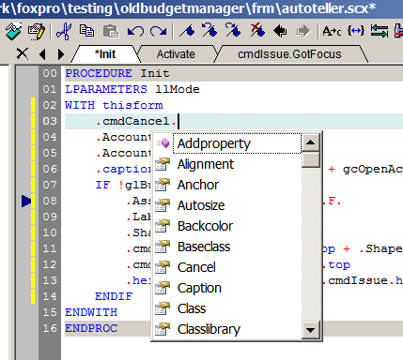
Member Lists:
Displays properties, methods, and objects for the object. Notice that the period is on a new line and displaying members for thisform

The Print Preview
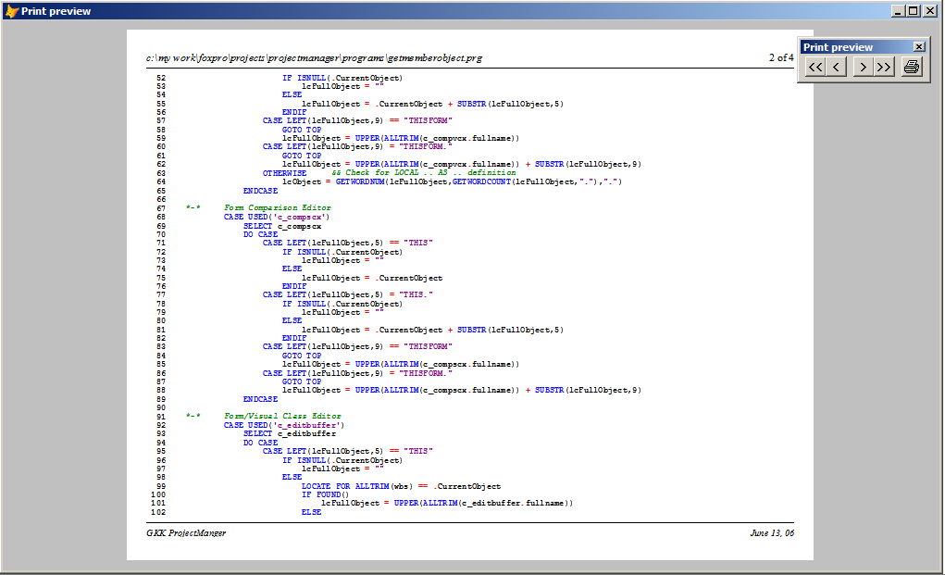

The Editor Context Menu
Editor has a right-click menu.

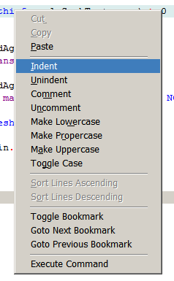

The GKK Form and Visual Class Editor Toolbar

Description of command buttons from left to right:

- Open Form – provides for a File Open dialog and a drop-down MRU list of files
- Save command
- Save-As command
- Print command – allows for printing current method, selection of text in method, or any/all methods. Provides portrait or landscape, page numbers, smart word-wrap, font selection, and support for color.
- Add method – allows adding custom or stock methods for forms and objects.
- Add method from… – allows adding custom or stock methods from another form or visual class
- Display/Edit inherited method – toggles between display of the inherited method in a pop-up form (if inherited method is edited) and display of inherited method.
- Edit custom properties – provides form for defining/editing custom properties. Included are property types with builder for color, font, etc.
- Memberdata editor – allows editing the memberdata information (provides support for problem of oversize limit of 8K)
- Cut current method to clipboard
- Copy current method to clipboard
- Paste method from clipboard
- Undo command
- Redo command
- Toggle bookmark on/off
- Goto next bookmark from current position
- Goto previous bookmark from current position
- Clear bookmarks
- Go back line – provides navigation based on user’s historical cursor movement
- Go forward line – provides navigation based on user’s historical cursor movement
- Toggle case of selected text
- Goto matching pair – provides navigation between matching parenthsis and code blocks (Ctrl-[)
- Set tab order – form for setting the tab order of objects
- Find – quick search for current selected text
- Find – allows search for text in current method, object, or form (support for regular expressions)
- Find Increment – Toggles on incremental search
- Replace text – replaces text
- Goto line – popup for line entry
- Show whitespace – toggles whitespace display on/off
- Get syntax for Win32 API DECLARE DLL command
- Beautiy command (indentation, case of keywords/symbols, and in-line comment alignment to column)
- Modify form – executes the MODIFY FORM command and hides the GKK Form Editor; re-reads form for changes when MODIFY FORM closed
- User preferences for editor
- About dialog

The GKK Form Editor Treeview Right-Click Menu
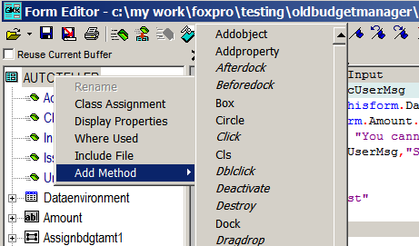  Form Right-Click Menu | 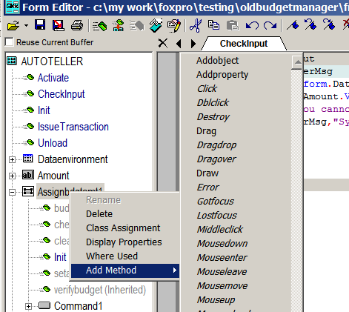  Object on Form Right-Click Menu

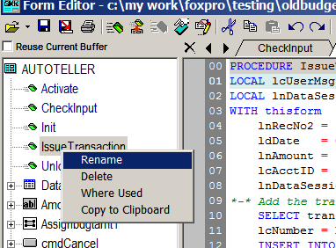
Method Right-Click Menu

The Right-Click menu options:
Rename | Allows for renaming of object or method. Provides for prompted replace function to update references in form or visual class
Class Assignment | Allows changing the class defined for the object; cannot change the base class
Display Properties | Provides for display of the selected object properties. This can be on the editor or in a pop-up form (configuration option).
Where Used | Provides for a ‘Where Used’ list. This can be on the editor or in a pop-up form (configuration option). Quick Navigation to code location is supported on the Where Used list by double-clicking on the item.
Include File | Allows adding or deleting an Include file. Include file is listed with the form or visual class on the treeview display.
Add Method | Allows adding a stock method based on the object. Events are italicized.
Delete | Allows deleting the object or the method.
Copy to clipboard | Copies the method code to the standard windows clipboard.

The GKK Procedure Editor Toolbar

Description of command buttons from left to right:

- DocView Toggle – opens or closes the DocView navigation Treeview on left; when opening it will refresh the navigation list
- Create – provides for creating a new procedure (PRG) file
- Open file – provides for a File Open dialog and a drop-down MRU list of files
- Save command
- Save-As command
- Print command – allows for printing current procedure. Provides portrait or landscape, page numbers, smart word-wrap, font selection, and support for color.
- Cut to clipboard
- Copy to clipboard
- Paste from clipboard
- Undo command
- Redo command
- Toggle bookmark on/off
- Goto next bookmark from current position
- Goto previous bookmark from current position
- Clear bookmarks
- Go back line – provides navigation based on user’s historical cursor movement
- Go forward line – provides navigation based on user’s historical cursor movement
- Indent selection
- Unindent selection
- Toggle case of selected text
- Goto matching pair – provides navigation between matching parenthsis and code blocks (Ctrl-[)
- Find – quick search for current selected text
- Find – allows search for text in current method, object, or form (support for regular expressions)
- Find Increment – Toggles on incremental search
- Replace text – replaces text
- Goto line – popup for line entry
- Show whitespace – toggles whitespace display on/off
- Get syntax for Win32 API DECLARE DLL command
- Beautiy command (indentation, case of keywords/symbols, and in-line comment alignment to column)
- Compile procedure – displays compile errors in list at bottom of editor
- User preferences for editor
- About dialog

The GKK Menu Editor
The GKK Menu Editor provides for all menu editing functions in an easy to use interface. Features included are easy treeview display of menu structure, menu branch copy/cut and paste (can be copied between two menus being edited), menu icon assignments (corrects bug in VFP), and easy access to all menu editing commands/features.

GKK Menu Editor Toolbar

Provides access to all menu edit functions:

- Create – provides for creating a new menu (MNU) file
- Open file – provides for a File Open dialog and a drop-down MRU list of files
- Print menu – provides for printing a report of the menu
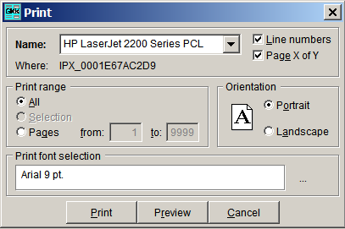
- Save menu
- Cut menu node/branch to clipboard (internal managed clipboard – shared between instances of the GKK Menu Editor)
- Copy menu node/branch to clipboard (internal managed clipboard – shared between instances of the GKK Menu Editor)
- Paste menu node/branch from clipboard (internal managed clipboard – shared between instances of the GKK Menu Editor)
- Insert menu pad – inserts a menu pad at the selected position on the Treeview menu structure
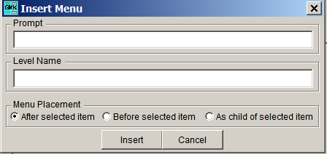
- Insert menu bar – inserts a menu bar at the selected menu pad on the Treeview menu structure
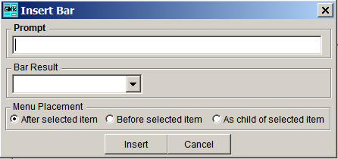
- Delete menu item (bar or pad) – deletes the select menu item
- Search menu – locates text in menu
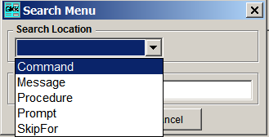
- Search again – repeats last selected menu search
- Generate menu – uses the _GENMENU assignment to generate a menu (MPR)
- About dialog
- Menu location – Replace, Append, Before, or After
- Menu placement – Standard VFP menu pads: File, Edit, View, Tools, Program, Window, Help
- Top-Level Form – allows for setting menu to be assigned to a top-level form

GKK Menu Print Preview

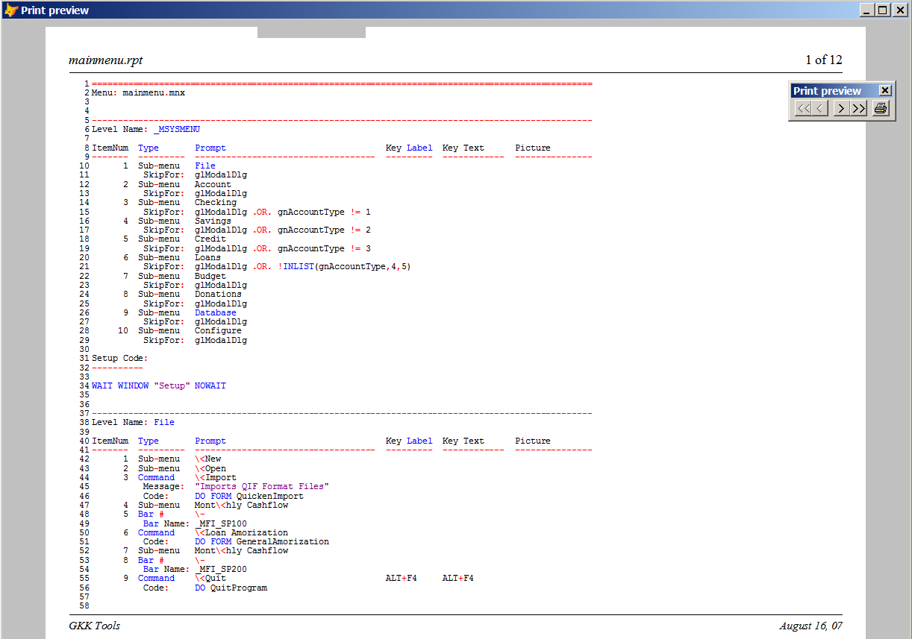

The GKK Comparison Editor

The comparison editor can be executed with or without command line parameters. If no parameters are provided, then a prompt for the type of comparison will be provided. To call with parameters:

DO GKKCompare WITH “c:\my files\firstfile.scx”, ”c:\my files\secondfile.scx”, PRJTYPE_FORM

Where the third parameter is defined by the following:

#DEFINE PRJTYPE_CLS "C"
#DEFINE PRJTYPE_FORM "K"
#DEFINE PRJTYPE_PROGRAM "P"
#DEFINE PRJTYPE_TABLE "D"
#DEFINE PRJTYPE_VCX "V"

Using the Mouse
Editor supports the following mouse actions:

Mouse Action: | Result:
L-button click over text | Changes the caret position
R-button click | Displays the right click menu
L- button down over selection, and drag | Moves text
Ctrl + L-button down over selection, and drag | Copies text
L-Button click over left margin | Selects line
L-Button click over left margin, and drag | Selects multiple lines
Alt + L-button down, and drag | Select columns of text
L- button double click over text | Select word under cursor
Spin IntelliMouse mouse wheel | Scroll the window vertically
Single click IntelliMouse mouse wheel | Select the word under the cursor
Double click IntelliMouse mouse wheel | Select the line under the cursor
Ctrl + Spin IntelliMouse mouse wheel | Increase or decrease text font size
L-button down and drag splitter bar | Split the window into multiple views or adjust the current splitter position
Double click splitter bar | Split the window in half into multiple views or unsplit the window if already split
L-button click or Ctrl+ L-button click over hyperlink | Navigate a hyperlink

Keyboard Navigation Mappings

Command | Keystroke
Move between edit buffers | Alt + PgUp or Alt + PgDn
Move between procedures/ functions/classes in editor buffer | Ctrl + PgUp or Ctrl + PgDn

Default Keyboard Mappings

Command | Keystroke
BookmarkNext | Ctrl + K + N
BookmarkNext | F2
BookmarkPrev | Ctrl + K + P
BookmarkPrev | Shift + F2
BookmarkToggle | Ctrl + K + K
BookmarkToggle | Ctrl + F2
CharLeft | Left
CharLeftExtend | Shift + Left
CharLeftExtendCol | Shift + Alt + Left
CharRight | Right
CharRightExtend | Shift + Right
CharRightExtendCol | Shift + Alt + Right
ChooseCommand | Ctrl + D
CommentSelection | Ctrll + K + C
CompleteWord | Ctrl + Space
Copy | Ctrl + C
Copy | Ctrl + Insert
Cut | Shift + Delete
Cut | Ctrl + X
CutSelection | Ctrl + Alt + W
DefineLocalVar | Alt + 6
Delete | Delete
DeleteBack | Backspace
DeleteLine | Alt + X
DeleteToEOL | Ctrl + Y
DocumentEnd | Ctrl + End
DocumentEndExtend | Ctrl + Shift + End
DocumentStart | Ctrl + Home
DocumentStartExtend | Ctrl + Shift + Home
Find | Alt + F3
Find | Ctrl + F
FindAgain | Ctrl + G
FindNext | F3
FindNextWord | Ctrl + F3
FindPrev | Shift + F3
FindPrevWord | Ctrl + Shift + F3
FindReplace | Ctrl + Alt + F3
FindReplace | Ctrl + H
GoToLine | Ctrl + L
GoToMatchBrace | Ctrl + ]
Help (VFP help) | F1
Home | Home
HomeExtend | Shift + Home
IncrementalSearch | Ctrl + I
IndentSelection | Tab
JumpToNextMethod | Ctrl + PgDn
JumpToPreviousMethod | Ctrl + PgUp
JumpToNextEditBuffer | Alt + PgDn
JumpToPreviousEditBuffer | Alt + PgUp
LineDown | Down
LineDownExtend | Shift + Down
LineDownExtendCol | Shift + Alt + Down
LineEnd | End
LineEndExtend | Shift + End
LineOpenAbove | Ctrl + Shift + N
LineUp | Up
LineUpExtend | Shift + Up
LineUpExtendCol | Shift + Alt + Up
ListMembers | Ctrl + J
LowercaseSelection | Alt + L
PageDown | Next
PageDownExtend | Shift + Next
PageUp | PRIOR
PageUpExtend | Shift + Prior
Paste | Ctrl + V
Paste | Shift + Insert
Properties | Alt + Enter
QuickInfo | Ctrl + K + I
RecordMacro | Ctrl + Shift + R
Redo | Ctrl + Shift + Z
Redo | Ctrl + Y
ReverseIncrementalSearch | Ctrl + Shift + I
Save | Ctrl + S
SelectAll | Ctrl + A
SelectLine | Ctrl + Alt + F8
SelectSwapAnchor | Ctrl + Shift + X
SentenceCut | Ctrl + Alt + K
SentenceLeft | Ctrl + Alt + Left
SentenceRight | Ctrl + Alt + Right
SetRepeatCount | Ctrl + R
ToggleCase | Alt + T
ToggleOvertype | Insert
ToggleWhitespaceDisplay | Ctrl + Alt + T
UncommentSelection | Ctrl + K + U
Undo | Ctrl + Z
Undo | Alt + Backspace
UnindentSelection | Shift + Tab
UppercaseSelection | Alt + U
WindowScrollDown | Ctrl + Up
WindowScrollLeft | Ctrl + PageUp
WindowScrollRight | Ctrl + PageDown
WindowScrollUp | Ctrl + Down
WordDeleteToEnd | Ctrl + Delete
WordDeleteToStart | Ctrl + Backspace
WordLeft | Ctrl + Left
WordLeftExtend | Ctrl + Shift + Left
WordRight | Ctrl + Right
WordRightExtend | Ctrl + Shift + Right

Regular Expression Syntax Rules
The regular expression implementation in Editor is a partial implementation of Perl regular expressions. The following syntax rules are supported:

Metacharacters
\ | Quote the next metacharacter
. | Match any character
| | Alternation (OR’d expression)
() | Grouping
[] | Set of characters. For example, ”[0123a-z]” will match 0, 1, 2, 3 and all lowercase alphabet characters. If first character is ‘^’, none of the specified characters must be present in order to match.
^ | Match the beginning of the line.
$ | Match the end of the line

Quantifiers (greedy)
* | Match 0 or more times
+ | Match 1 or more times
? | Match 0 or 1 times
{n} | Match exactly n times
{n,} | Match at least n times
{n,m} | Match at least n but not more than m times

By default, a quantified subpattern is “greedy”, meaning it will match as many times as possible while still allowing the rest of the pattern to match. If you wish for a regular expression to match the minimum number of times possible, follow the quantifier with a question mark (‘?’).

Quantifiers (non-greedy)
*? | Match 0 or more times
+? | Match 1 or more times
?? | Match 0 or 1 times
{n}? | Match exactly n times
{n,}? | Match at least n times
{n,m}? | Match at least n but not more than m times

Escape sequences
\t | match a tab character
\w | Match a "word" character (alphanumeric plus "_")
\W | Match a non-"word" character
\s | Match a whitespace character
\S | Match a non-whitespace character
\d | Match a digit character
\D | Match a non-digit character
\b | Match a word boundary
\B | Match a non-(word boundary)
\a | Match only at beginning of line
\z | Match only at end of line

